**Assignment 1: Learning and Memory PSY 306 (Winter 2024)**

**Name:**

**Roll Number:**

**Instructions:** Please write your own responses and DO NOT copy or lift text/code from any source, including the attached paper. If you are referring to credible external sources other than the attached paper for your answers, please cite those sources (within the body of text and the provide a reference list at the end) in the APA citation format (<https://www.mendeley.com/guides/apa-citation-guide>). Word limits given are indicative and less than the indicated numbers may also be used.

**Please download this MS word question-cum-response template to TYPE your answers and feel free to add sheets as required. Convert this document to a PDF and rename the file: name_roll no. before submitting. Please note that answers in this template only will be evaluated and hand-written or scanned answer sheets will not be evaluated. Verbatim copying of any extent and total percent similarity with other sources exceeding 20% will be deemed plagiarized and dealt as per IIITD policies.**

**[Strict deadline for submission: 14 Feb, 12 PM Noon]**

**Part A)**

Fill out[**this Google form**](https://forms.gle/NiyEZtMEVSDEvtsV9)for Part A

**Part B)**

As a part of a working memory study, 17 subjects performed a change detection task. The description of the task is as follows.

Each trial of the task consisted of a study(2), retention(3), and test phase(4). Each trial began with the presentation of a cue followed by the memory array consisting of colored blocks followed by a blank time interval. Participants were asked to report whether the rectangle in the test display changed orientation/color or not from the sample displayed at the same position by pressing one of two response keys. The task consists of a total of 192 trials with 4, 6 and 8 set sizes(test conditions) in the memory array for each participant.

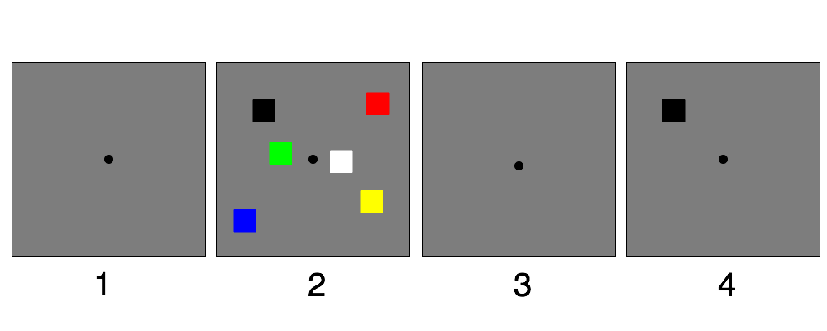

Attached ‘LM_A1_data.mat file’ contains data of 17 participants (p1…p17). Each participant’s data comprises 3 variables. In all variables, each column represents one block of 48 trials and there are a total of 4 blocks (48(trials)*4(blocks)=192 trials). The 3 variables are:

‘setSize’ : - Array set sizes: 4, 6, and 8.

‘change’: - 1= change in color/ position occurred; 0 = 'no change' occurred.

‘accuracy’ : - 1 = correct response/correct trial; 0 = incorrect response/incorrect trial.

*** The students who are facing difficulty reading ‘.mat’ files may use the ‘.xlsx’ data files.

Here is the description of the ‘.xlsx’ files

There are 3 excel files named *all_participants_data_setSize, all_participants_data_change, all_participants_data_accuracy.* Each sheet in the file contains data of one participant, and there are a total of 17 sheets in each file. Each column of the sheet represents one block containing 48 trials and there are a total of 4 blocks.

*all_participants_data_setSize:* 4,6,8 set sizes

*all_participants_data_change:* 1-change occurred; 0-no change occurred

*all_participants_data_accuracy:* 1-correct response/ trial, 0 – incorrect response/ trial

[ links about importing MATLAB data arrays into Python and R

<https://in.mathworks.com/help/matlab/matlab_external/matlab-arrays-as-python-variables.html>

<https://stackoverflow.com/questions/11671883/importing-an-array-from-matlab-into-r> ]

Now solve the following. Insert a figure (wherever required) and paste the MATLAB/Python/R code. **Any figure must provide all information necessary to interpret it including axes labels with units, captions/legends. Comment the sections of your code explicitly to convey the key steps.**

**1a)**

Calculate the percent of total correct trials for each array set size for each participant and then the mean percent of total correct trials across all participants. Plot a simple bar diagram to represent the mean percent of total correct trials across all participants along with the standard error of the mean (as error bars) for each condition. [4 points]

[Answer]

**1b)**

To compare the mean percent correct trials (across participants) across three conditions, conduct an appropriate statistical test and report the results with the appropriate test statistics and p values. Based on a comparison of the accuracies in all conditions, what can be concluded about the relationship between response accuracy and visual working memory capacity from the experimental data? [3+2+1 points]

[Hint: Check for assumptions of appropriate statistical test stepwise to conduct a test followed by appropriate post-hoc test as discussed in the class to solve the above. Indicate the main steps in your code with clear comments.]

[Answer]

**2a)**

Calculate the ‘d prime’ for each array size for all trials for each participant and average ‘d prime’ across participants. Create a bar diagram for each array size showing mean ‘d prime’ (across participants) and standard error of the mean as error bars. [5 points]

[Answer]

**2b)**

To compare the mean ‘d prime’ (across participants) across three conditions (array size), conduct an appropriate statistical test and report the results with test statistics and p values. Interpret the results of the test statistics. [2+2+1 points]

[Hint: Check for assumptions of appropriate statistical test stepwise to conduct a test followed by appropriate post-hoc test as discussed in the class to solve the above. Indicate the main steps in your code with clear comments.]

[Answer]